36.25: a) Interference maxima: Diffraction minima:
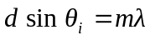 and 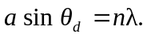
If the 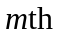interference maximum corresponds to the 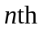diffraction minimum then 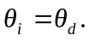
or 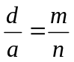
so
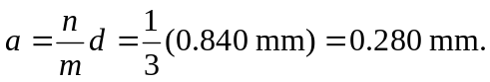
b) The diffraction minima will squelch the interference maxima for all 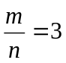 up to the highest seen order. For 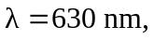the largest value of will be when 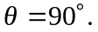
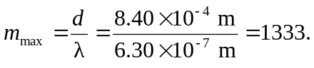
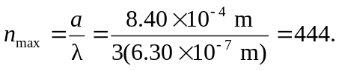
So after will also be missing.
c) By changing we only change the highest order seen.
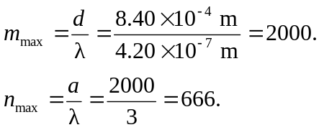
So

